**Descriptive Statistics**

1. Sales drag it into rows.
2. We don’t want a bar chart we want a table, so we use ‘show me’ and select table.
3. You will see TOTAL SALES (SUM)
4. Let’s change SUM to AVG:
5. We get the mean
6. To find the median we click on sale and drag it into rows again. Change Sum to Median
7. Select table from ‘show me’, you’ll see a table
8. Rename Avg. Sales to Mean Sales.

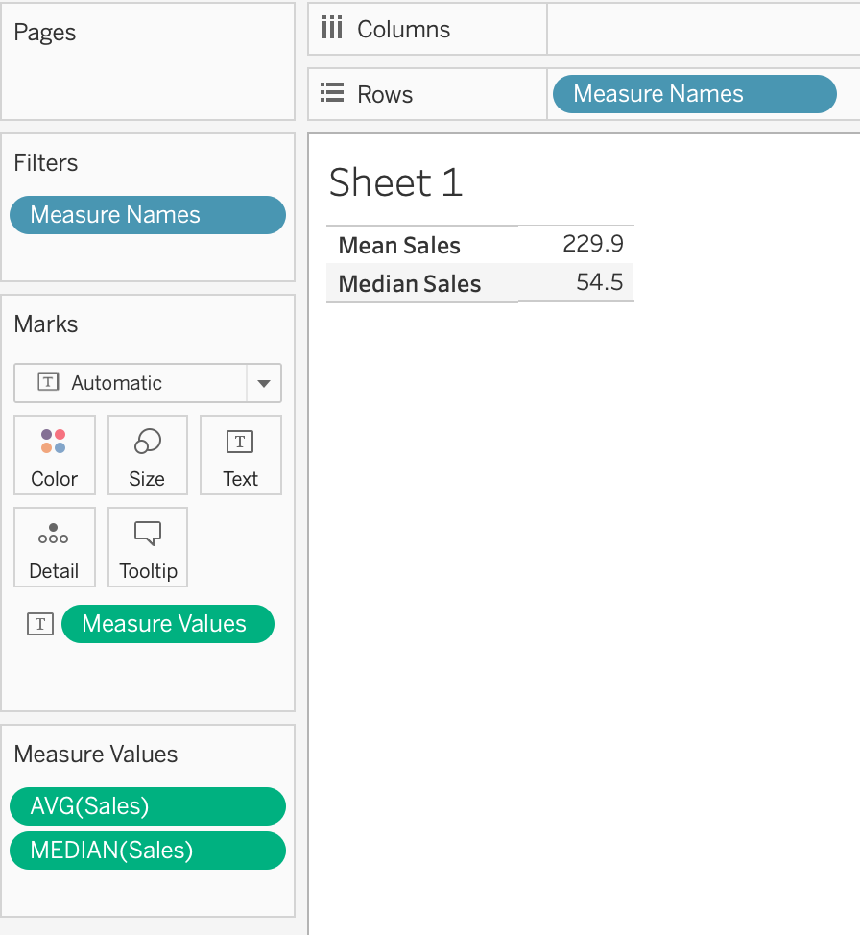

You want to look at your variables to see if they are normal distributed. Build a table for your descriptive stats (Discount, Profit, Quantity & Sales), support your findings with respective histograms for all your variable.

**Descriptive Analytics**

## **Histogram**

A histogram is a chart that displays the shape of a distribution. A histogram looks like a bar chart but groups values for a continuous measure into ranges, or bins.

In Tableau you can create a histogram using **Show Me**.

1. Connect to the **Sample - Superstore** data source.
2. Drag **Quantity**to **Columns**.
3. Click **Show Me** on the toolbar, then select the histogram chart type.

The histogram chart type is available in **Show Me** when the view contains a single measure and no dimensions.

Three things happen after you click the histogram icon in **Show Me**:

* The view changes to show vertical bars, with a continuous x-axis (1 – 14) and a continuous y-axis (0 – 5,000).
* The **Quantity** measure you placed on the **Columns** shelf, which had been aggregated as SUM, is replaced by a continuous **Quantity (bin)** dimension. (The green color of the field on the **Columns** shelf indicates that the field is continuous.)

To edit this bin: In the Data pane, right-click the bin and select **Edit**.

* The **Quantity** measure moves to the **Rows** shelf and the aggregation changes from SUM to CNT (Count).

The **Quantity** measure captures the number of items in a particular order. The histogram shows that about 4,800 orders contained two items (the second bar), about 2,400 orders contained 4 items (the third bar), and so on.

Let's take this view one step further and add **Segment** to **Color** to see if we can detect a relationship between the customer segment (consumer, corporate, or home office) and the quantity of items per order.

1. Drag **Segment**to **Color**.

The colors don't show a clear trend. Let's show the percentage of each bar that belongs to each segment.

1. Drag **Quantity** field to **Label**.
2. Right click > Quick Table Calculation > Percent of Total.

But we want the percentages to be on a per-bar basis.

1. Right-click the **CNT(Quantity)** field on the **Marks** card again and select **Edit Table Calculation**.
2. In the Table Calculation dialog box, change the value of the **Compute Using** field to **Cell**.

Now each colored section of each bar shows its respective percentage of the total quantity:

There is still no evidence that the percentages by customer segment show any trend as the number of items in an order increase.

SCATTER PLOT

**Scatter Plot**

Column > sum(sales)

Row > sum(profit)

(Remember the point is the aggregation of both variables. Go to Analysis and uncheck aggregate measures).

Customer name to details

Encoding

Segment to colors

Sales to size

Category to shape

On your visualizations always look at your x & y axis. You find info. i.e. quantity sold, outliers/extreme values, etc…

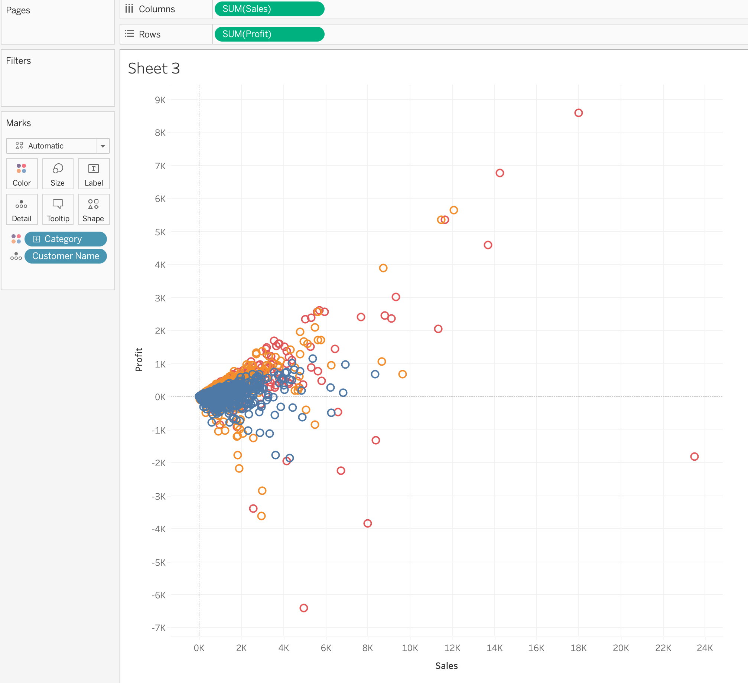

**Box & Whisker**

Select a variable let’s say Quantity and look at show me.

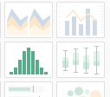

We need the visualization next to the histogram. If it is not available, uncheck on analysis, aggregated measures.

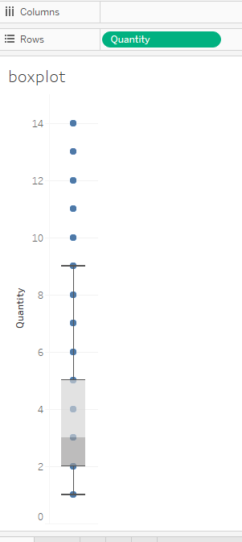

Select a dimension, for example Region and drop it in columns.

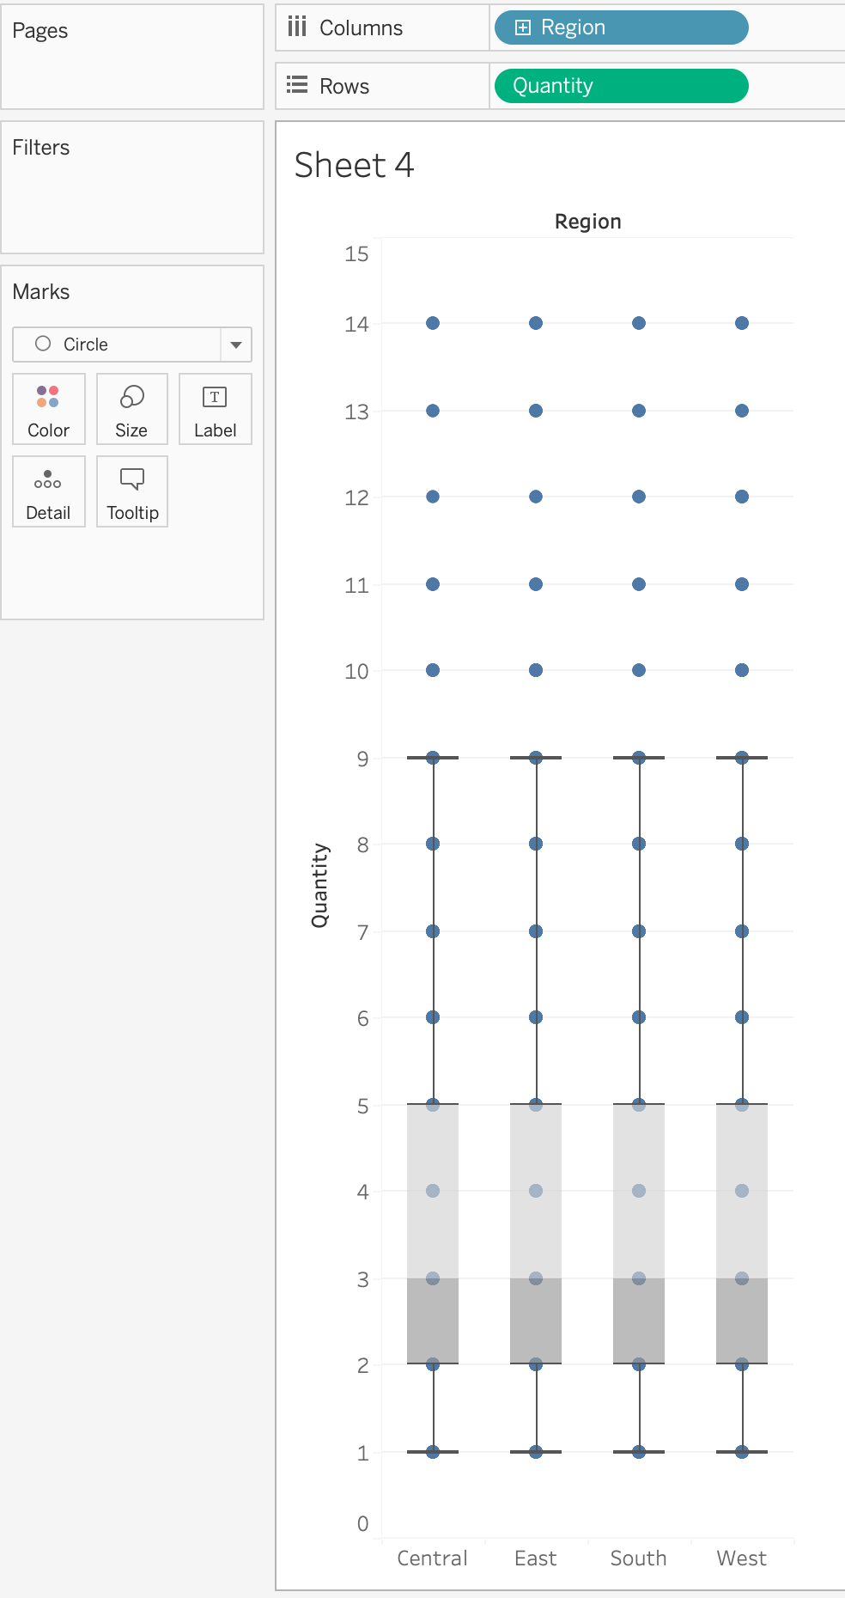

Describe what you see. Look at the shaded areas and whiskers.

**Correlations Matrix**

Shows relationship between variables. Visualization will tell if variables are linear correlated, positive or negative, any sort of relationship, etc.

Take a variable, drag & drop it in the columns and rows. Do this for each variable. Them uncheck aggregated measures.

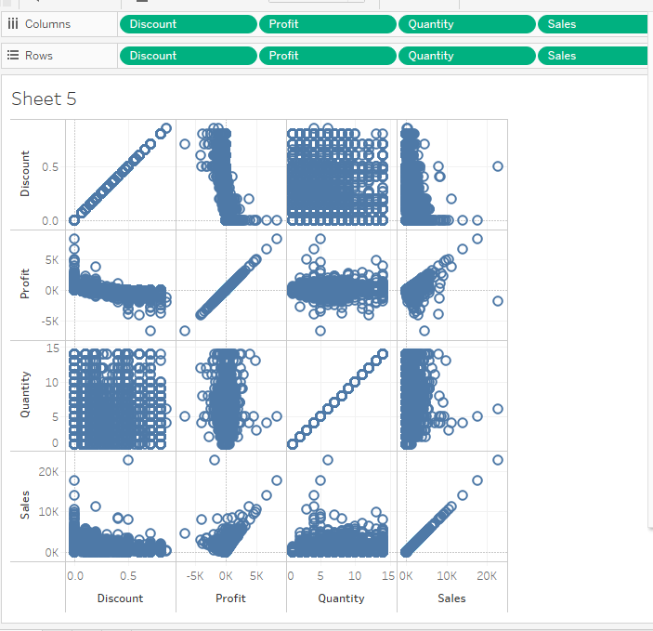

**Correlation in Tableau**

**What is correlation?**

Correlation is a statistical measure that indicates the extent to which two or more variables are related. The measure of correlation between two variables is called correlation coefficient. Pearson’s correlation coefficient is one of the most widely used and measures only the linear correlation between two variables, while the other correlation might also measure nonlinear relationship.

**Types of Correlation:**

The value of correlation coefficient ranges from -1 to 1. On the basis of the values of correlation coefficient we have three types of correlation:

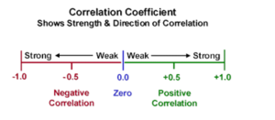

1- Negative Correlation: Two variables are said to be negatively correlated if the value of the correlation coefficient is between 0 and -1.

2- Zero Correlation: two variables are said to be not correlated if the value of correlation coefficient between them is 0.

3- Positive Correlation: Two variables are said to be positively correlated is the value of the correlation coefficient is between 0 and 1.

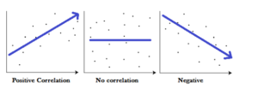

**Benefits and Practical Use of Correlation:**

There are several advantages of correlation, the first being it is simple to calculate and easy to interpret. It also helps us in making predictions.  
On the other hand we need to bit a bit cautious while using correlation.  The value of the correlation 0 implies that there is no linear relationship between the variables, however there could be some non linear relationship between the variables. Secondly correlation could be spurious in nature as well. There may be a high correlation between two variables still their relationship would not make any sense. For example there may be a positive correlation between height and income of individuals, however this seems quite illogical.

**Correlation and Causation**

Correlation is, “A statistical measure (expressed as a number) that describes the size and direction of a relationship between two or more variables. While causation “Indicates that one event is the result of the occurrence of the other event; i.e. there is a causal relationship between the two events. This is also referred to as cause and effect.” The classic causation vs correlation example that is frequently used is that smoking is correlated with alcoholism but doesn’t cause alcoholism. While smoking causes an increase in the risk of developing lung cancer.

**Correlation In Tableau:**The classical formula to determine the correlation between two variables is

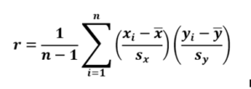

Here x and y represent the two variables, Sx and Sy represent the standard deviation of  x and y . And n denotes the sample size. X bar and Y bar represent the mean of X and Y respectively.

To use this formula in tableau we will break the formula in four parts . This is how it is done:  
The first part of the formula is denoted  by

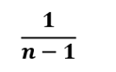

Which in the language of tableau can be written as 1/(SIZE()-1). The size function in tableau tells us about the sample size.

The next part of the formula is

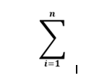

Which is equivalent to the WINDOWSUM function in Tableau  
The third part of the formula is

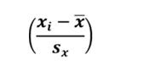

Assuming this be a measure profit in our data the formula can be rewritten as:  
(SUM([Profit])-WINDOW_AVG(SUM([Profit]))) / WINDOW_STDEV(SUM([Profit])))  
Similarly the fourth part of the formula can be written as we wrote our third part.  
Let’s go to tableau and use this formula for calculating the correlation coefficient.

Step 1: Build our View  
Let’s open our tableau workbook and use our default Data set “Sample Super Store” data.  
Once we have our data connected, drag the measure Sales to column and Profit to rows. Place Customer Name on the details mark. Drag the dimension Segment to column in front of Sum(Sales) which is already present in the column.  
Your view will now be as under:

Let s go ahead and create a calculated field to compute the correlation coefficient as under:

﻿1/(SIZE()-1) *

WINDOW_SUM((sum([Profit]) - WINDOW_AVG(SUM([Profit])))

/ WINDOW_STDEV(SUM([Profit]))) *

(SUM([Sales]) - WINDOW_AVG(SUM([Sales]))) /

WINDOW_STDEV(SUM([Sales]))

Next drag this field to color and compute it across Customer Name. Our view will now be as under:

Here can see the colors of the dots for the three segments to be different. The color denotes the strength of the correlation coefficient. The darker the dots, the higher the strength of correlation.  
We can also add reference lines and bring in other dimensions to see how the two measures are correlated in other dimensions.

**Summary:**

* The best way to measure the relationship between two continuous variables is through correlation.
* Correlation can be between -1 and 1
* The closer the value to -1 or 1, the stronger is the correlation.
* Correlation is not causation.

**TRANSFORMATIONS**

To transform our variable to a log, create a calculation. Click table on show me and remove check from aggregated measures.

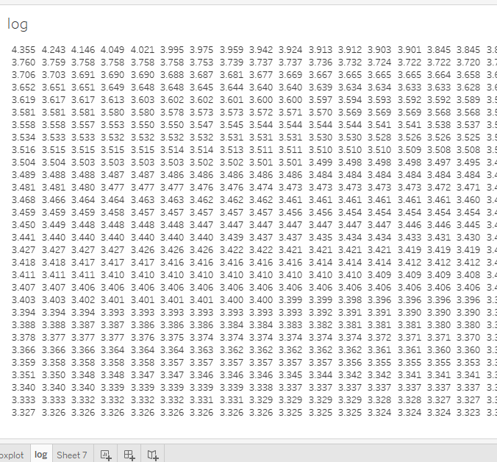

Calculate Z-scores

In statistics, the z-score (or standard score) of an observation is the number of standard deviations that it is above or below the population mean.

To calculate a z-score you must know the population mean and the population standard deviation. In cases where it is impossible to measure every observation of a population, you can estimate the standard deviation using a random sample.

The basic equation to calculate a z-score is…

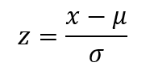

…where X is the SUM(profit), Sigma () is the standard deviation and Mu () is the mean.

Create a z-score visualization to answer questions like the following:

* What percentage of values fall below a specific value?
* What values can be considered exceptional? For example, in an IQ test, what scores represent the top five percent?
* What is the relative score of one distribution versus another? For example, Michael is taller than the average male and Emily is taller than the average female, but who is relatively taller within their gender?

As a general rule, z-scores lower than -1.96 or higher than 1.96 are considered unusual and interesting. That is, they are statistically significant outliers.

To calculate a z-score in Tableau.

1. Connect to the **Sample - Superstore** data source provided with Tableau Desktop.
2. Create a calculated field to calculate average sales.

Choose **Analysis** > **Create Calculated Field** to open the calculation editor. Name the calculation **Average Sales** and type or paste the following in the formula area:

WINDOW_AVG(SUM([Sales]))

1. Create another calculated field to calculate the standard deviation. Name the calculation **STDEVP Sales** and type or paste the following in the formula area:

WINDOW_STDEVP(SUM([Sales]))

1. Create one more calculated field, this one to calculate the z-score. Name the calculation **Z-score** and type or paste the following in the formula area:

(SUM([Sales]) - [Average Sales]) / [STDEVP Sales]

1. Drag **Z-Score** from the **Data** pane to **Columns.** Make a copy of the variable Sales and drop it on the dimension side of the panel. Sales on measures provides aggregation no needed. Have **Sales** copy into **Rows**. Click table.

Notice that the **Z-score** field on Columns has a table calculation icon on the right side (that is, a small triangle):



The **STDEVP Sales** function is based on the **WINDOW_STDEVP** function, which is a table calculation function. The **Z-Score** function, in turn, is a table calculation function because it includes **STDEVP Sales** in its definition. When you use a calculated field that includes a table calculation function in a view, it's the same as adding a table calculation to a field manually. You can edit the field as a table calculation. In fact, that's what you do next.

1. Click the **Z-score** field on Columns and choose **Compute Using** > **Sales**.

This causes the z-scores to be computed on a per-state basis.

1. Click the **Sort Descending** icon on the toolbar:



1. Hold down the Ctrl key and drag the **Z-score** field from **Columns** to **Color**.

Ctrl + Drag copies a field as currently configured to an additional location.

1. Ctrl + Drag **Z-score** from Columns once again. This time drop it on **Label**.

You now have a distribution of z-scores broken out by state. California and New York both have z-scores greater than 1.96. You could conclude from this that California and New York have significantly higher average sales than other states.

**Sorting Stacked Bars**

Sorting of stacked bars charts enable us to see the composition of the trend of the dimension that we want to have a look at. We will use our sample super store data for this. Before we go to sorting of the stacked bars, lets first try to build it.

To do that follows these steps:

1- Drag order date to the columns. Right click on the Date pill in the columns and select Month from the dropdown.  
2- Drag sales to the rows and change the mark type to bars.  
Your screen at this point will look like this:

3- Now let’s drag region to the colors mark.  
4- Right click on the sales pill in the rows and add a quick table calculation percentage of totals. Compute it along Region.

You should now have this on your screen:

Now we see in the above charts that the bars are not sorted. What we want to achieve is that for the month of Jan we have Central at the top then South, then West and finally east as the sales in east is the lowest in the month of Jan. Similarly, it should be for all the months. To do that follow the steps as under:

5- Create a calculated field as under:

7- Move calculation month to dimensions.

Create a combined field using region and Month that we created in the above step. To create a combined field Ctrl click on Region and Month >> Right click and then from the dropdown select create combined field.

8- Drag the combined field Region &Month to detail.  
9- Drag the field region to detail.  
10- Right click on the Region & Month Field on the details mark and then click on sort. Select descending and sort by Sales (sum)

